Quantinel: A Hybrid Quantum–Classical Machine Learning Framework for Intrusion Detection and Similarity-Based Attack Characterization

1. Introduction and Background
Cybersecurity systems face increasingly sophisticated attacks, making reliable intrusion detection an important research problem. Traditional Intrusion Detection Systems (IDS) and classical machine learning models perform well for known attack patterns but often struggle with previously unseen attacks, limited behavioural understanding, and generalization beyond the training data.
Recent advances in Quantum Machine Learning (QML) have introduced quantum feature maps and kernel-based methods that may provide richer feature representations for similarity analysis. This motivates investigating whether quantum techniques can improve the characterization of unknown attack behaviour.
Quantinel is a hybrid quantum-classical framework that integrates:
- Classical Machine Learning for intrusion detection.
- Classical and quantum similarity methods for attack-family characterization.
- Comparative evaluation of classical and quantum approaches on previously unseen attacks.
Rather than identifying only whether traffic is malicious, the framework aims to characterize unseen attacks by mapping them to the most behaviourally similar known attack family.

2. Motivation & Research Gap

Most intrusion detection research focuses on supervised classification of known attack categories. However, practical deployment presents several challenges:
- Most IDS models assume a closed-set classification problem and are evaluated only on attacks seen during training.
- Previously unseen attacks are difficult to characterize beyond simply identifying them as malicious.
- Similarity-based attack family characterization has received comparatively little attention.
- Applications of Quantum Machine Learning for intrusion detection remain limited, particularly for similarity-based analysis.
- Rare attack families such as R2L and U2R continue to be difficult to classify due to severe class imbalance.

3. Objective

- Develop a classical intrusion detection baseline using Random Forest.
- Implement classical similarity methods (Cosine Similarity and KNN).
- Implement a QSVC-based quantum characterization pipeline.
- Compare classical and quantum similarity methods on unseen attack families.
- Investigate whether quantum kernel methods improve attack-family characterization over classical similarity methods.

4. Proposed Methodology

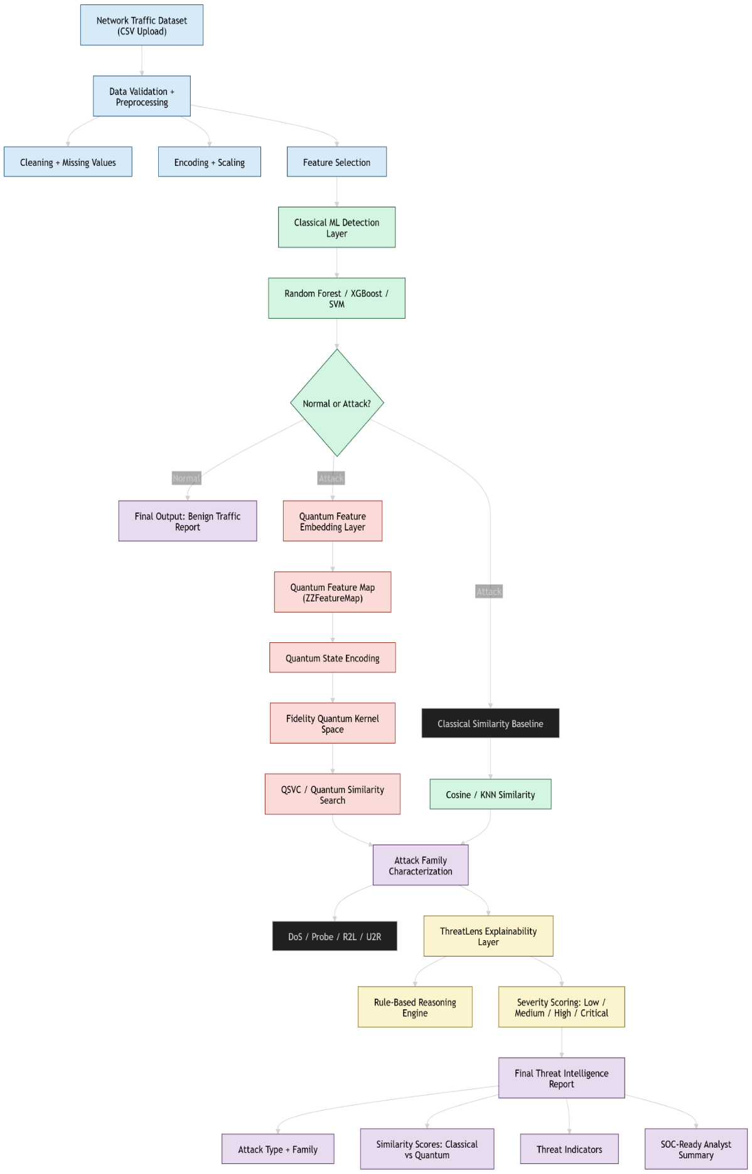

4.1 Classical Intrusion Detection Layer

A classical intrusion detection pipeline was developed using the NSL-KDD dataset to classify network traffic as Attack or Normal. Random Forest, SVM, Logistic Regression and XGBoost were evaluated, with Random Forest achieving the best overall performance (approximately 77% accuracy) and selected as the baseline detection model.
Analysis of the results showed reduced recall for several attack categories because 15 attack types present in the NSL-KDD test set are not available in the training set, limiting the model's ability to recognize previously unseen attacks.

4.2 Similarity Analysis Framework

The similarity-based characterization layer is designed to address a key limitation of supervised intrusion detection: previously unseen attack types cannot be assigned an exact attack label because they are absent from the training data. Instead of attempting exact classification, the objective is to characterize an unseen attack by assigning it to the most behaviourally similar known attack family (DoS, Probe, R2L or U2R). This provides analysts with meaningful information about the nature of an unknown attack even when its exact label is unavailable.
The implemented pipeline consists of the following steps:
- The detected attack samples undergo the same preprocessing as the classical intrusion detection model, followed by PCA to reduce the feature dimensionality for quantum processing.
- ZZFeatureMap encodes the reduced feature vectors into quantum states, enabling attack behaviour to be represented in a quantum feature space.
- The Fidelity Quantum Kernel computes pairwise similarity between quantum states, producing a similarity matrix based on the quantum feature representation.
- Quantum Support Vector Classification (QSVC) uses this kernel matrix to characterize each attack into its closest attack family.
- For comparison, two classical similarity methods, Cosine Similarity and K-Nearest Neighbours (KNN), have also been implemented and evaluated on the same unseen attack set.

4.3 Research Objective

The central research question of this work is:

"Can quantum kernel-based feature embeddings improve attack-family characterization of previously unseen network attacks compared to classical similarity methods such as Cosine Similarity and K-Nearest Neighbours?"

This study investigates the representational capability of quantum kernel methods rather than computational speed, with the objective of determining whether quantum feature spaces produce more meaningful attack-family characterization.

4.2 Attack Family Characterization

Attack characterization is performed at the family level (DoS, Probe, R2L and U2R) rather than predicting individual attack labels. Since several attack types in the NSL-KDD test set are absent from the training data, assigning an exact label is often not possible. Instead, the similarity layer maps each unseen attack to its closest known family based on behavioural similarity, providing more meaningful context for analysis than a simple Attack/Normal prediction.

5. Expected Outcomes

- Establish a reliable classical intrusion detection baseline using the NSL-KDD dataset.
- Compare classical and quantum similarity methods for attack-family characterization.
- Evaluate the ability of QSVC to characterize previously unseen attacks.
- Assess the practical feasibility and limitations of Quantum Machine Learning for cybersecurity applications.

6. Current Progress

Completed
- Data preprocessing and feature engineering on the NSL-KDD dataset.
- Classical intrusion detection model for attack detection (Attack vs Normal) using Random Forest.
- Evaluation of multiple classical classification models (Random Forest, SVM and Logistic Regression) for intrusion detection.
- Classical attack-family characterization using Cosine Similarity and K-Nearest Neighbours (KNN).
- Open-set evaluation using attack types present only in the NSL-KDD test set.
- Implementation and initial evaluation of Quantum Support Vector Classification (QSVC) for attack-family characterization.

Current Status
- The classical intrusion detection pipeline has been completed and evaluated.
- Classical similarity-based attack characterization using Cosine Similarity and KNN has been implemented and evaluated on unseen attack families.
- The QSVC-based quantum characterization pipeline has been implemented and is currently being optimized through experimentation with feature selection, dimensionality reduction (PCA), quantum feature maps and kernel configurations.

